28 Zaroug and Munns--Rhizobium for Clitoria and Vigna
SCREENING STRAINS OF RHIZOBIUM FOR THE TROPICAL LEGUMES CLITORIA TERNATEA AND VIGNA TRILOBATA IN SOILS OF DIFFERENT pH
M. G. ZAROUG* AND D. N. MUNNS* ABSTRACT
Several strains of Rhizobium were greenhouse-tested on clitoria (Clitoria ternatea) and phillipesara (Vigna trilobata) to determine effectiveness in a soil of pH 6.3 that was N-deficient but otherwise fertile. Selected strains were further tested on phillipesara in an acid soil, unlimed or limed to pH 6.6.
Yield of N and visual ratings of shoot growth and color gave similar ratings of effectiveness. Variations of effectiveness did not relate to variation in nodule number, nodule weight, or rates of acetylene reduction when the acid soil was used.
In soil at pH 6.3 four strains that were highly effective on clitoria outyielded the NH₄,NO₃, control treatment. With phi'llipesara the best strains yielded 75% as much as the NH₄NO₃ control. In the acid soil, symbiotic performance of strains ranked differently than in the neutral soil. Liming the acid soil depressed plant growth.
INTRODUCTION

Phillipesara (Vigna trilobata) and clitoria (Clitoria ternatea) are potentially important irrigated forage legumes in the Sudan (Musa and Burhan 1974). Both are high-yielding and vigorous competitors with associated weeds under rainfed conditions; and phillipesara has shown promise as a pasture legume either mixed with Cenchrus ciliaris or directly seeded into native grasslands (M. G. Zaroug, unpublished). Success in these roles will depend on the natural occurrence or introduction of strains of Rhizobium able to persist and nodulate with high effectiveness under a variety of soil conditions including acidity.
Favorable effects of calcium and increased pH on nodulation are well documented for both tropical and temperate legume species (Hutton and Andrew 1978, Munns 1978). Lime-induced depression of plant growth has been reported also (Kamprath 1971, Munns and Fox 1976, Hutton and Andrew 1978).
This report describes tests of effectiveness of Rhizobium strains with phillipesara and clitoria grown in a neutral sandy soil, and performance of selected strains with phillipesara in an acid soil.

MATERIALS AND METHODS

Rhizobium strain effectiveness on clitoria and phillipesara

Eleven strains for clitoria and 13 for phillipesara were tested, with uninoculated and plus nitrogen checks. Treatments were replicated three times in a completely random design. Tujunga sand (pH 6.3 in saturated paste) collected at Davis, California from the top 30 cm, was screened, air-dried, and dispensed into pots lined with polyethylene bags at 1.7 kg of soil per pot. Each pot received 20 ppm S and 4 ppm P as K₂SO₄ and KH₂PO₄ solutions. Each pot was mixed and watered to field capacity (18.5 % ) before being planted.
Clitoria seeds (from the Department of Range Management, Khartoum, Sudan), were scarified with concentrated H₂SO₄ for 15 minutes and planted five per

* Department of Land, Air and Water Resources, University of California, Davis, CA 95616 USA. Senior author is now with Department of Range Management, P.O. Box 199, Khartoum, Sudan.
pot. Seeds of phillipesara were surface sterilized in H₂0₂ for 6 minutes. Pure cultures of rhizobial strains were applied in suspension at 10⁴ cells per seed. A week after emergence, seedlings were thinned to three per pot. The plus N controls received 200 ppm N as NH₄NO₃ solution directly after thinning. Distilled water was used to bring soil to field capacity by weight every second day.
The appearance of yellow coloration with green midribs on clitoria leaflets indicated zinc or iron deficiency. This was corrected by foliar spraying with a mixture of 0.5% ZnS0₄, 0.5% FeS0₄ and wetting agent.
Eight weeks from planting, tops were removed and oven dried at 70°C for 24 hours. Roots were washed for determination of nodule number and fresh weight.

Nodulation of phillipesara in an acid soil

Pots containing 1600 g of Goldridge fine sand (pH 4.7 in saturated paste) were used. This soil was calcium-deficient, mildly aluminium toxic but neither manganese toxic nor molybdenum deficient (Munns, et al. 1979). Calcium carbonate was added to half the pots at the rate of 3 g kg⁻¹ of soil. Then all pots were watered to 70% of field capacity and allowed to equilibrate for one week (pH 6.6). Each pot then received 20 ppm S and 60 ppm P as K₂S0₄ and KH₂P0₄ solutions. Two days later the soils were mixed and rewatered to field capacity. Ten seeds of phillipesara were planted and inoculated in each pot, and thinned after emergence to six plants. Ammonium nitrate was added to the plus nitrogen controls in two doses, 100 ppm N directly after thinning and an equal amount ten days later. Ten strains of Rhizobium were assayed.
Plants were harvested eight weeks from planting. Roots were washed and blotted for acetylene reduction assays (by incubation for one hour in 0.1 atmosphere acetylene in air). Then nodule number and fresh weight were determined. Kjeldahl nitrogen analyses were done on shoot material (McKenzie and Wallace 1954).
RESULTS
Effectiveness of rhizobia on clitoria

There were large differences between strains (Table 1) . Some strains were very effective. Four of them (TAL 173, 29B2, TAL 200 and TAL 305) exceeded the nitrogen-treated plants in dry matter production but the difference was significant (P < 0.05) for strain TAL 173 only. Some strains were poorly effective.
Nitrogen content also varied between the different treatments. Five strains (173, 29B2, 305, 200 and 169) gave nitrogen yields not significantly (P < 0.05) less than the nitrogen-treated plants. Nitrogen yield, plant color and dry weight yield gave similar rankings of strain effectiveness. Effectiveness bore little relationship to nodule number, weight or distribution.
Effectiveness of rhizobia on phillipesara
As for clitoria there were large differences in nitrogen content and dry matter yield (Table 2). Effectiveness ranked similarly according to plant dry matter, nitrogen content or color. By contrast with clitoria, nodule fresh weight correlated with nitrogen content significantly (r = 0.70, P < 0.05) ; and plant yield correlated significantly with both nodule fresh weight (r = 0.73, P < 0.05) and nodule number (r = 0.67, P < 0.05). Nitrogen yield of the plus N plants exceeded that from any of the inoculants (Table 2).
Ability of selected rhizobia to nodulate phillipesara in an acid soil
All strains except CB1024 (Fig. 1) nodulated phillipesara in acid Goldridge soil, some better than others. As in Tujunga soil, no strain gave plant yields as high as the N-control treatment. One strain, CB1024, failed completely. Liming the Goldridge soil reduced nodulation, and also reduced growth in most treatments including
Tropical Grasslands Vol. 14, No. 1, March 1980
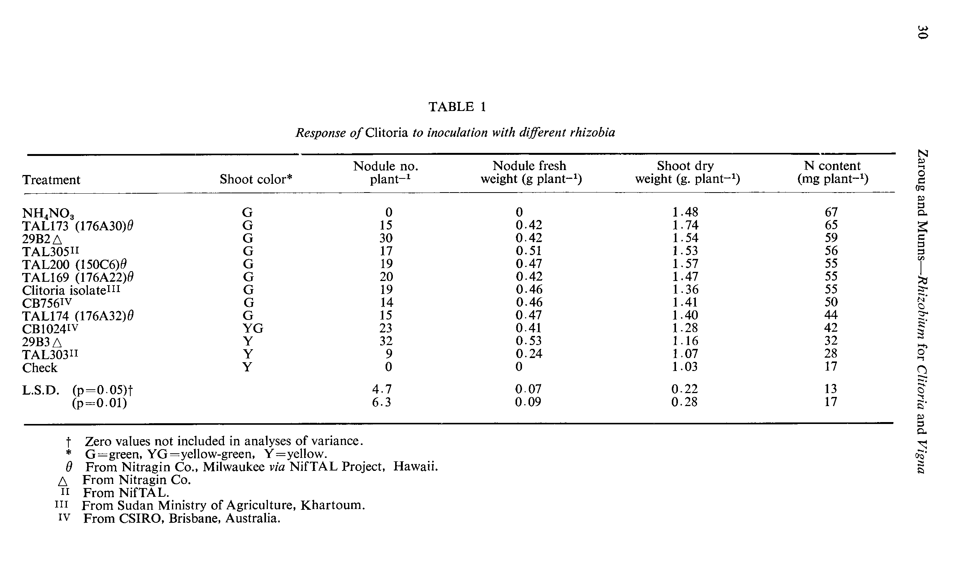
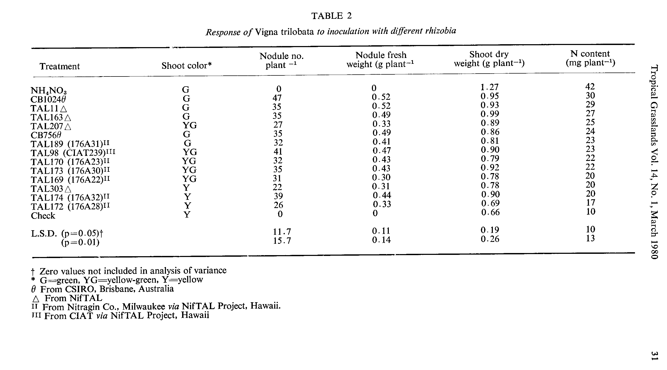
DISCUSSION

Effectiveness on clitoria

Measurements of nodule number, nodule fresh weight or weight of individual nodules did not indicate effectiveness of symbiosis in clitoria. Small nodules were produced by both highly effective (29B2) and ineffective (29B3) strains; and strain 29B3 though ineffective had the largest nodule mass. Discrepancy between nodule mass and effectiveness has been reported for soybean and subterranean clover (Gibson 1977) and mung (Munns et al. 1979). Correlations between nodule number or mass and plant dry matter yield are evidently species-dependent.

Effectiveness on phillipesara

Phillipesara grew normally in the acid soil with N supplied, but not when it was symbiotically dependent. The rhizobial strains differed in response to low soil pH. In
Tropical Grasslands Vol. 14, No. 1, March 1980 33
particular strain CB1024, one of the most effective in neutral soil, failed completely in the acid Goldridge soil as expected from its known acid-sensitivity (Keyser and Munns 1979). Some strains, particularly TAL 163, combined a degree of acid tolerance with high effectiveness in association with phillipesara.
Strain 127D4, which nodulated abundantly in the absence of lime, nevertheless produced a low plant N content, perhaps because of impaired nodule activity. This effect has been noted elsewhere, along with the more usually encountered depression of nodule formation (Munns 1978).
Decline in nodulation in the unlimed Goldridge soil when compared to Tujunga sand might be explained by the effect of low pH and aluminium toxicity on Rhizobium survival and growth (Keyser and Munns 1979) and the possible interference by acidity, aluminium and low calcium with one of the steps later than the colonization of the rhizosphere (Munns et al. 1979). The sparse nodulation when Goldridge soil was limed was more likely to result from curtailment of shoot growth and the observed reduction in root mass.
Reduction in growth and nodulation as a result of high rates of lime has been observed for several legume species (Kamprath 1971, Munns and Fox 1976, Hutton and Andrew 1978). In this case it was not accompanied by any symptoms of nutrient
deficiency or toxicity. The negative response to liming in this trial does not imply that phillipesara is in general intolerant of high soil pH. In Sudan it has been grown satisfactorily on alkaline heavy clay soils (Zaroug, unpublished).
ACKNOWLEDGEMENT
This work was partly supported by the U.S. Agency for International Development through the University of Hawaii NifTAL Project. We are grateful for rhizobia supplied by Dr. J. C. Burton of the Nitragin Co. Milwaukee, Wisconsin; Drs. R A.
Date and H. V. A. Bushby of CSIRO Brisbane; and Drs. T. L. Wacek and V. V. Reyes of NifTAL.
REFERENCES
GIBSON, A. H. (1977) -Limitations to dinitrogen fixation by legumes. In Proceedings of the First International Symposium on Nitrogen Fixation. Ed. W. E. Newton and C. J. Nyman (Washington State University Press). Vol. 1, pp. 400-423.
HUTTON, E. M. and ANDREW, C. S. (1978)-Comparative effects of calcium carbonate on growth, nodulation and chemical composition of four legumes. Australian Journal of Experimental Agriculture and Animal Husbandry 18: 81-88.
KAMPRATH, E. J (1971) -Potential detrimental effects of liming highly weathered soils to neutrality. Soil and Crop Science Society of Florida Proceedings 31: 200-203.
KEYSER, H. H. and MUNNs, D. N. (1979)-Tolerance of rhizobia to acidity, aluminum and phosphate. Soil Science Society of America journal 43: 519-523.
MASEFIELD, G. B. (1955)-Conditions affecting the nodulation of leguminous crops in the field. Empire Journal of Experimental Agriculture 23: 17-24.
M.KENzIE, H. A. and WALLACE, H. S. (1954)-Kjeldahl determination of nitrogen: a critical study of digestion conditions. Australian Journal of Chemistry. 7: 55-70.
MUNNs, D. N. (1978)-Soil acidity and nodulation. In "Mineral Nutrition of Legumes in Tropical and Subtropical Soils". Ed. C. S. Andrew and E. J Kamprath (CSIRO: Melbourne, Australia). pp. 247-263.
MUNNs, D. N. and Fox, R. L. (1976)-Depression of legume growth by liming. Plant and Soil 45: 701-705.
MUNNs, D. N., KEYSER, H. H., FOGLE, V. W., HOHENBERG, J S., RIGHETTI, T. L., LAUTER, D. L., ZAROUG, M. G., CLARKIN, K. L. and WHITACRE, K. A. (1979)-Tolerance of soil acidity in symbioses of mung bean with rhizobia. Agronomy Journal 71: 256-260.
MUSA, M. M. and BURHAN, H. O. (1974)-The relative performance of forage legumes as rotational crops in the Gezira. Experimental Agriculture 10: 131-140.
(Accepted for publication September 21, 1979)

